Project 2

INDIVIDUAL PROJECT

MARVIN HOPE

219445842

Contents

**CODING EVIDENCE:**

For the coding part, we as a group as decided to use android studios because we are developing an app on android. In the coding section I will display the pseudo code and the flow chart.

**WIRE FRAME:**

In the wireframe section, this is the blueprint of how the Schedule page will look like.

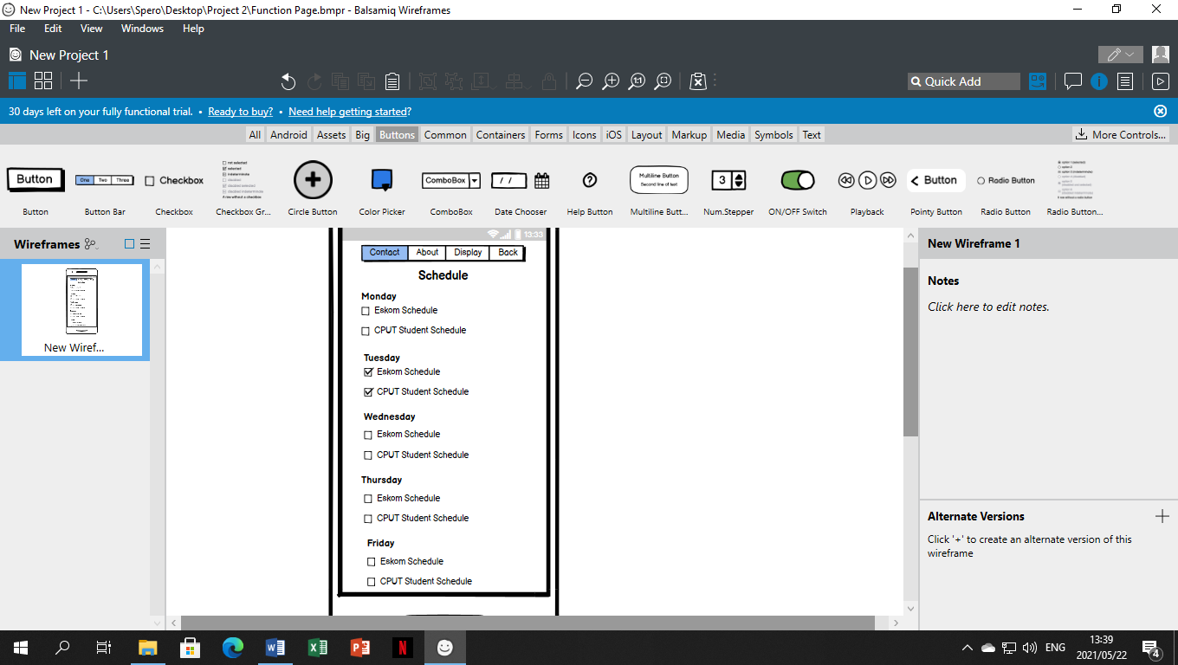

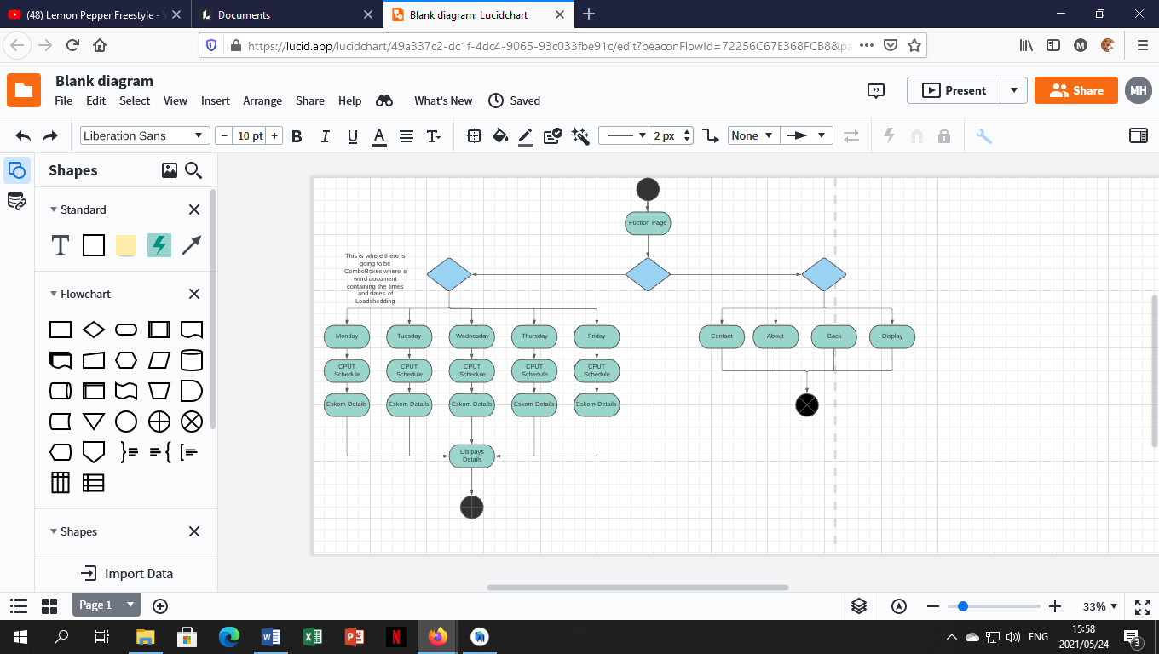**PSEUDO CODE AND FLOW CHART:**

**CODE:**

<?xml version="1.0" encoding="utf-8"?>  
<androidx.constraintlayout.widget.ConstraintLayout xmlns:android="http://schemas.android.com/apk/res/android"  
 xmlns:app="http://schemas.android.com/apk/res-auto"  
 xmlns:tools="http://schemas.android.com/tools"  
 android:layout_width="match_parent"  
 android:layout_height="match_parent"  
 tools:context=".MainActivity">  
  
 <ImageView  
 android:id="@+id/imageView2"  
 android:layout_width="1080dp"  
 android:layout_height="1920dp"  
 app:srcCompat="@drawable/dd"  
 tools:layout_editor_absoluteX="0dp"  
 tools:layout_editor_absoluteY="0dp" />  
  
 <androidx.appcompat.widget.Toolbar  
 android:id="@+id/toolbar2"  
 android:layout_width="409dp"  
 android:layout_height="47dp"  
 android:background="?attr/colorPrimary"  
 android:minHeight="?attr/actionBarSize"  
 android:theme="?attr/actionBarTheme"  
  
 tools:layout_editor_absoluteX="1dp"  
 tools:layout_editor_absoluteY="0dp" />  
  
 <TextView  
 android:id="@+id/textView3"  
 android:layout_width="123dp"  
 android:layout_height="38dp"  
 android:text="Schedule"  
 android:textColor="@color/cardview_dark_background"  
 android:textSize="28dp"  
 android:textStyle="bold"  
 tools:layout_editor_absoluteX="144dp"  
 tools:layout_editor_absoluteY="5dp" />  
  
 <ImageView  
 android:id="@+id/imageView3"  
 android:layout_width="67dp"  
 android:layout_height="27dp"  
 app:srcCompat="@drawable/ic_baseline_menu"  
 tools:layout_editor_absoluteX="21dp"  
 tools:layout_editor_absoluteY="12dp" />  
  
 <ImageView  
 android:id="@+id/imageView5"  
 android:layout_width="74dp"  
 android:layout_height="34dp"  
 app:srcCompat="@drawable/ic_baseline_arrow_forward"  
 tools:layout_editor_absoluteX="321dp"  
 tools:layout_editor_absoluteY="5dp" />  
  
 <TextView  
 android:id="@+id/textView4"  
 android:layout_width="wrap_content"  
 android:layout_height="wrap_content"  
 android:text="Monday"  
 android:textColor="@color/white"  
 android:textSize="20dp"  
 android:textStyle="bold"  
 tools:layout_editor_absoluteX="16dp"  
 tools:layout_editor_absoluteY="60dp" />  
  
 <CheckBox  
 android:id="@+id/checkBox"  
 android:layout_width="wrap_content"  
 android:layout_height="wrap_content"  
 android:text="Eskoms Schedule"  
 android:textColor="@color/white"  
 android:textSize="18dp"  
 android:textStyle="bold"  
 tools:layout_editor_absoluteX="16dp"  
 tools:layout_editor_absoluteY="87dp" />  
  
 <CheckBox  
 android:id="@+id/checkBox"  
 android:layout_width="wrap_content"  
 android:layout_height="wrap_content"  
 android:text="CPUT Schedule"  
 android:textColor="@color/white"  
 android:textSize="18dp"  
 android:textStyle="bold"  
 tools:layout_editor_absoluteX="16dp"  
 tools:layout_editor_absoluteY="135dp" />  
  
 <TextView  
 android:id="@+id/textView4"  
 android:layout_width="wrap_content"  
 android:layout_height="wrap_content"  
 android:text="Wednesday"  
 android:textColor="@color/white"  
 android:textSize="20dp"  
 android:textStyle="bold"  
 tools:layout_editor_absoluteX="16dp"  
 tools:layout_editor_absoluteY="306dp" />  
  
 <CheckBox  
 android:id="@+id/checkBox"  
 android:layout_width="wrap_content"  
 android:layout_height="wrap_content"  
 android:text="Eskoms Schedule"  
 android:textColor="@color/white"  
 android:textSize="18dp"  
 android:textStyle="bold"  
 tools:layout_editor_absoluteX="16dp"  
 tools:layout_editor_absoluteY="210dp" />  
  
 <CheckBox  
 android:id="@+id/checkBox"  
 android:layout_width="wrap_content"  
 android:layout_height="wrap_content"  
 android:text="CPUT Schedule"  
 android:textColor="@color/white"  
 android:textSize="18dp"  
 android:textStyle="bold"  
 tools:layout_editor_absoluteX="16dp"  
 tools:layout_editor_absoluteY="258dp" />  
  
 <TextView  
 android:id="@+id/textView4"  
 android:layout_width="wrap_content"  
 android:layout_height="wrap_content"  
 android:text="Tuesday"  
 android:textColor="@color/white"  
 android:textSize="20dp"  
 android:textStyle="bold"  
 tools:layout_editor_absoluteX="16dp"  
 tools:layout_editor_absoluteY="183dp" />  
  
 <CheckBox  
 android:id="@+id/checkBox"  
 android:layout_width="wrap_content"  
 android:layout_height="wrap_content"  
 android:text="Eskoms Schedule"  
 android:textColor="@color/white"  
 android:textSize="18dp"  
 android:textStyle="bold"  
 tools:layout_editor_absoluteX="16dp"  
 tools:layout_editor_absoluteY="456dp" />  
  
 <CheckBox  
 android:id="@+id/checkBox"  
 android:layout_width="wrap_content"  
 android:layout_height="wrap_content"  
 android:text="CPUT Schedule"  
 android:textColor="@color/white"  
 android:textSize="18dp"  
 android:textStyle="bold"  
 tools:layout_editor_absoluteX="16dp"  
 tools:layout_editor_absoluteY="381dp" />  
  
 <TextView  
 android:id="@+id/textView4"  
 android:layout_width="wrap_content"  
 android:layout_height="wrap_content"  
 android:text="Thursday "  
 android:textColor="@color/white"  
 android:textSize="20dp"  
 android:textStyle="bold"  
 tools:layout_editor_absoluteX="16dp"  
 tools:layout_editor_absoluteY="429dp" />  
  
 <CheckBox  
 android:id="@+id/checkBox"  
 android:layout_width="wrap_content"  
 android:layout_height="wrap_content"  
 android:text="Eskoms Schedule"  
 android:textColor="@color/white"  
 android:textSize="18dp"  
 android:textStyle="bold"  
 tools:layout_editor_absoluteX="16dp"  
 tools:layout_editor_absoluteY="333dp" />  
  
 <CheckBox  
 android:id="@+id/checkBox"  
 android:layout_width="wrap_content"  
 android:layout_height="wrap_content"  
 android:text="CPUT Schedule"  
 android:textColor="@color/white"  
 android:textSize="18dp"  
 android:textStyle="bold"  
 tools:layout_editor_absoluteX="16dp"  
 tools:layout_editor_absoluteY="504dp" />  
  
 <TextView  
 android:id="@+id/textView4"  
 android:layout_width="wrap_content"  
 android:layout_height="wrap_content"  
 android:text="Friday "  
 android:textColor="@color/white"  
 android:textSize="20dp"  
 android:textStyle="bold"  
 tools:layout_editor_absoluteX="16dp"  
 tools:layout_editor_absoluteY="552dp" />  
  
 <CheckBox  
 android:id="@+id/checkBox"  
 android:layout_width="wrap_content"  
 android:layout_height="wrap_content"  
 android:text="Eskoms Schedule"  
 android:textColor="@color/white"  
 android:textSize="18dp"  
 android:textStyle="bold"  
 tools:layout_editor_absoluteX="16dp"  
 tools:layout_editor_absoluteY="579dp" />  
  
 <CheckBox  
 android:id="@+id/checkBox"  
 android:layout_width="wrap_content"  
 android:layout_height="wrap_content"  
 android:text="CPUT Schedule"  
 android:textColor="@color/white"  
 android:textSize="18dp"  
 android:textStyle="bold"  
 tools:layout_editor_absoluteX="16dp"  
 tools:layout_editor_absoluteY="627dp" />  
  
  
</androidx.constraintlayout.widget.ConstraintLayout>

**DESIGN:**

In the design page, this is where I will display the design of the function page.

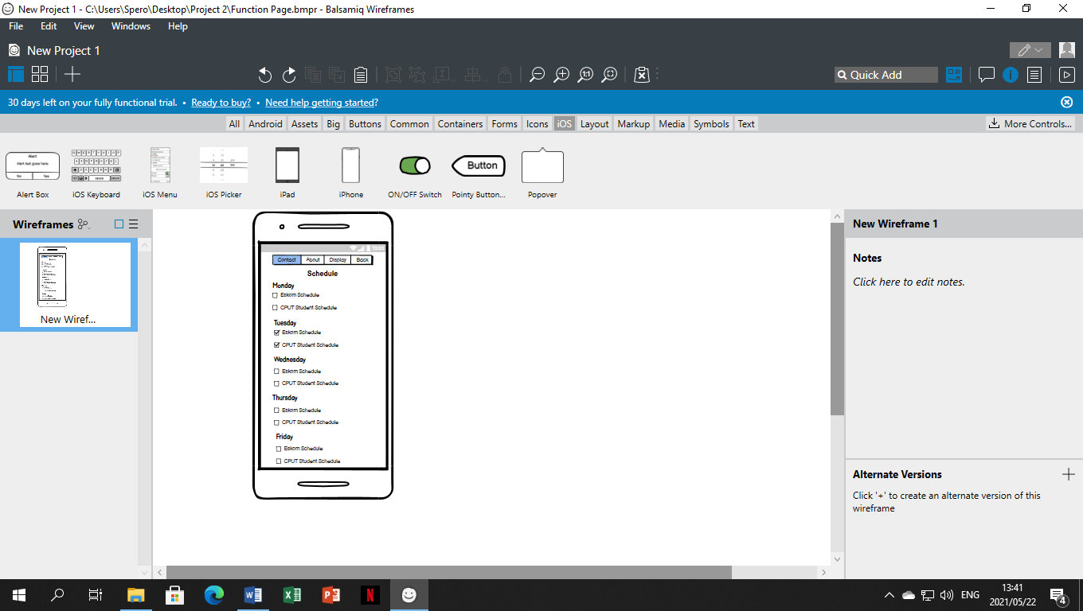

**COLOURS:**

At the colour section, this is where I will show what colours was used in the application.

These are the colours that I used:

#0EDDAC

#51E1E1

#E7EFEE

**FINAL DESIGN:**

In the final design page, this is where I will showcase the final product.

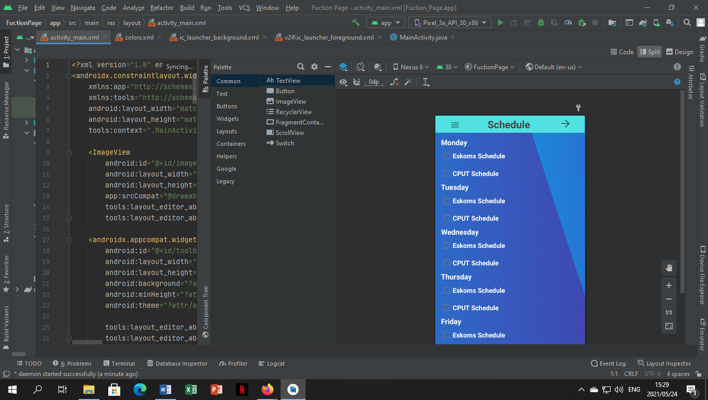

**REFLECTION:**

On the reflection page, this is where I will explain how I designed the page and how the page will work.

We as a group have decided to use android studios because our project is developing an application for CPUT users to use when there is load shedding.

In this application, it will have the load shedding times and stages when load shedding is going to occur at district 6 campus. Then there will be a student schedule where the student will adjust his timetable with the corresponding load shedding times.

In the design of the function page is where I have decided to use ComboBoxs because it is easier for the user to download the pdf document with the time and stages of load shedding.

**GROUPS GITHUB LINK:**

<https://github.com/Wareezy/Project2-Individual/upload/MarvinHope-219445842>